Exp.2 ***Christmas dual led chaser lights***

Circuit Diagram:

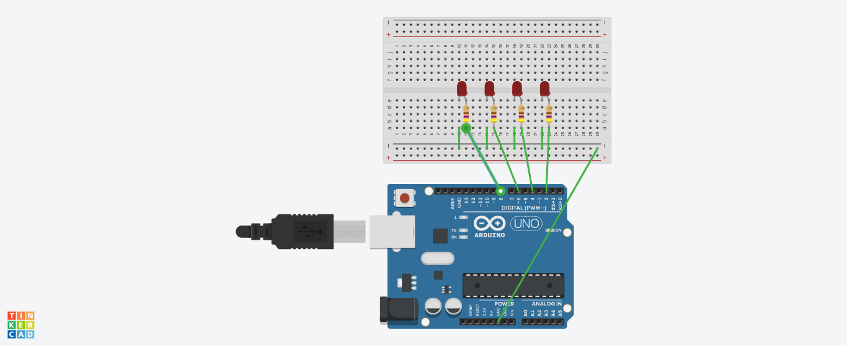

Theory:

Concept Used:

1)In this experiment I have used the concept of p-n junction diode.

2)How and Why resistance is used in a circuit.

3) To make a circuit on Bread Board.

4)Logic to code for Arduino UNO by using Loop statement.

Learning & Observations:

**Learning:**

1)I have learnt to use Arduino Board and how code works to glow LEDs in chaser light pattern.

2)How a circuit is placed on breadboard so that it can work properly.

3)Arduino board has Digital pins and Analog pins.

Digital pin provides Input as well as Output, but Analog pin provides only input.

4)The Arduino board has ~ sign in Digital pin side which is also known as Pulse Width Modulation(PWM)**.**

These pins help’s in getting analog results with digital means.

5)Since the LED can bear a limited supply of voltage so we have used resistance in series with the LED so that the voltage gets divided and LED can use the require amount of voltage.

**Observations:**

1)The Arduino board can provide a supply of 5V to the chaser circuit.

2)I connected the ‘p’ terminal of the p-n junction diodes to the Digital pins 2,4,6,8 in combination with the resistance, and ‘n’ terminals with the ground(GND).

3)After uploading the code on the Arduino software, the LEDs started blinking and moving forward inconsecutive manner with the time interval of 500milliseconds. They are moving in pair and giving the sense of LED chaser.



Problems and Troubleshooting:

1)The circuit on the bread board is not relevant so the circuit will not work.

I have fixed it by recognizing the circuit properly and again make the circuit on the board.

2)I got confused while using the void loop 2 times. The solution is that we can use ‘for’ loop in the function of void loop to overcome this problem.

3)I didn’t know how the delay function works and for that I removed the delay function and observed the result. I observed the result once again by using the delay function.

Precaution:

1)We need to handle the elements of the device with good care.

2)The connections on the Arduino board must coincide with the codes written on the software.

3)During the writing of the codes, the insertion of delay should not be forgotten and that too of the required time interval and not any random value.

4)In the IDE of Arduino the instructions should be given only in void loop section.

Learning and Outcomes:

1)I have learnt to make circuits using breadboard, Arduino board and other equipment.

2)I have learnt the various patterns of an LED chaser.

3)I have learnt to make other type of gadgets related to this concept.

4)I have learnt how we can use the Arduino board for doing various tasks.

5)I have learnt about the elements of Arduino board and its functions.